How to use BakBalls
Initially use BakBalls once every 2 days for no more than 5 minutes. Once tolerance increases you can use BakBalls daily for no more than 5 minutes. Ensure you don't use the BakBalls in only one area, move the BakBalls from the top to bottom of your back. For safety reasons, don't fall asleep on the BakBalls.
See also How to use - videos
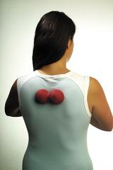 | STEP 1  Lie on your bed, or against a wall, and position BakBalls evenly between your shoulder blades in the upper thoracic section of your spine.
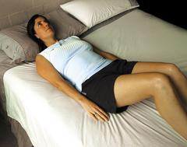 | STEP 2  Start by using the BakBalls on your bed and use a pillow if you suffer from neck pain. Bend your knees and keep arms by your sides to control pressure exerted from BakBalls.
STEP 3
Lie stationary on the BakBalls for 30 seconds, then push through your heels and roll the balls down your spine 2-3cm and repeat process until BakBalls are resting in your lower back. Once tolerance increases, you can increase pressure by moving to a carpeted floor. Don't roll vigorously on BakBalls.
STEP 4
To further increase the pressure from BakBalls, fold arms across your chest. This exposes the joints in the mid thoracic region to more therapeutic pressure. Gently roll to one side if you feel pain more on one side.
STEP 5
To maximally increase pressure (if you have progressed through steps 1-4), raise your arms overhead. This position is especially beneficial for swimmers, cyclists, runners and triathletes.
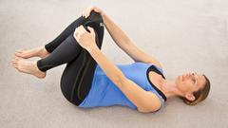 | How to relieve low back pain (lumbar region)

